Assignment 1 – Prepare Model Analysis Class Diagram

**Name**  – Yash Shivaji Lende

**Roll -No** – IT3116

**PRN**  – RBT22IT014

**Subject**  - Advance Software Modelling

**Class Diagram** – Patient Appointment Class diagram

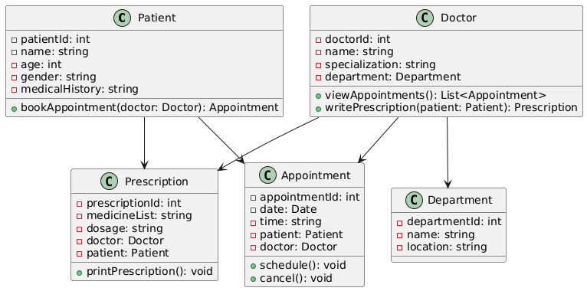

Workflow

1. **Patient**: Books appointments and receives prescriptions.
2. **Doctor**: Belongs to a department, sees patients, and writes prescriptions.
3. **Appointment**: Connects a patient and a doctor at a specific time.
4. **Prescription**: Contains medicine info written by a doctor for a patient.
5. **Department**: Groups doctors by specialization (e.g., Cardiology, Pediatrics).

Assignment 2 – Prepare Use Case Diagram

**Name**  – Yash Shivaji Lende

**Roll -No** – IT3116

**PRN**  – RBT22IT014

**Subject**  - Advance Software Modelling

**Use Case Diagram :** Online Shopping System

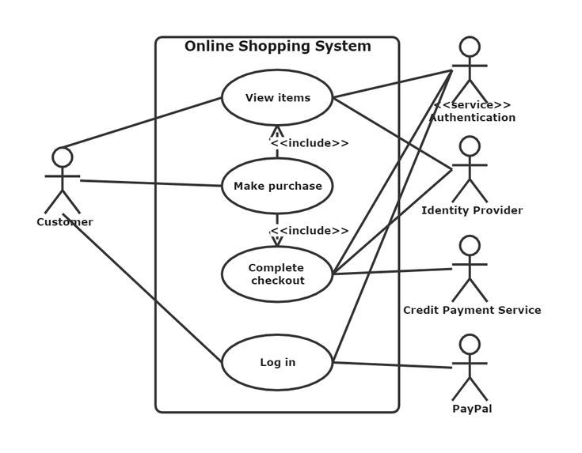

**Actors**

1. **Customer**: The main user who interacts with the system.
2. **Authentication Service** *(<<service>>)*: Provides login and security services.
3. **Identity Provider**: Likely handles third-party or federated identity management (e.g., Google login).
4. **Credit Payment Service**: Used for processing credit card payments.
5. **PayPal**: Another external payment provider.

**Use Cases**

* **View Items**: Customer browses the online catalog.
* **Make Purchase**: Central action for buying something.
  + Includes:
    - **View Items** (via <<include>>): You must view items before purchasing.
    - **Complete Checkout** (via <<include>>): Checkout is part of making a purchase.
* **Complete Checkout**: Finalize the purchase with payment and address confirmation.
* **Log in**: Authentication process for customer access.

Assignment 3 – Prepare State Model

**Name**  – Yash Shivaji Lende

**Roll -No** – IT3116

**PRN**  – RBT22IT014

**Subject**  - Advance Software Modelling

**State Machine Diagram** : Microwave Working

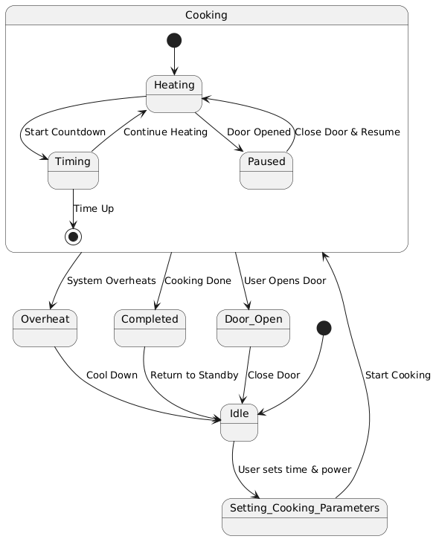

**Main States**

1. **Idle**: Microwave is waiting.
2. **Setting Cooking Parameters**: User sets time and power.
3. **Cooking**: Microwave is heating the food.
   1. Has internal states: *Heating*, *Timing*, *Paused*
4. **Completed**: Cooking is done.
5. **Overheat**: Safety state if the system gets too hot.
6. **Door Open**: User opens the door during cooking.

**State Transitions**

1. I**dle → Setting Cooking Parameters**: User inputs time/power.
2. **Setting → Cooking**: User starts cooking.
3. **Cooking → Completed**: Time is up.
4. **Cooking → Overheat**: System overheats.
5. **Cooking → Door Open**: User opens door.
6. **Door Open → Idle**: After door is closed.
7. **Completed/Overheat → Idle**: Ends process and returns to standby.

Assignment 4 – Prepare Sequence Model

**Name**  – Yash Shivaji Lende

**Roll -No** – IT3116

**PRN**  – RBT22IT014

**Subject**  - Advance Software Modelling

**Sequence Diagram** : User Login Sequence

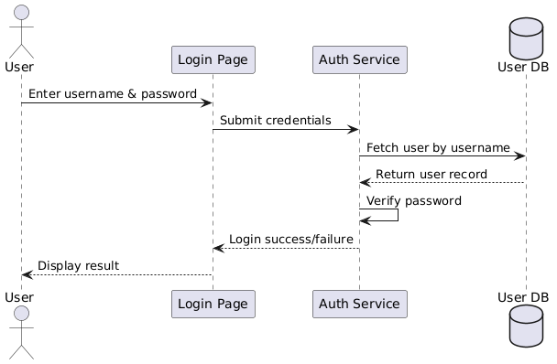

**Sequence Flow :**

1. **User → UI:** User enters their username and password on the login screen.
2. **UI → Auth Service**: The UI sends the entered credentials to the authentication service**.**
3. **Auth Service → DB:** The service queries the database for the username.
4. **DB → Auth Service:** The database returns the user record (including stored hash).
5. **Auth Service:** Verifies the input password by comparing it with the stored hash**.**
6. **Auth Service → UI:** Sends the result of the login attempt (success or failure).
7. **UI → User:** Displays the result (e.g., "Welcome!" or "Invalid credentials").

Assignment 5 – Prepare Activity Diiagram

**Name**  – Yash Shivaji Lende

**Roll -No** – IT3116

**PRN**  – RBT22IT014

**Subject**  - Advance Software Modelling

**Activity Diagram** : Hospital Patient Admission Process,

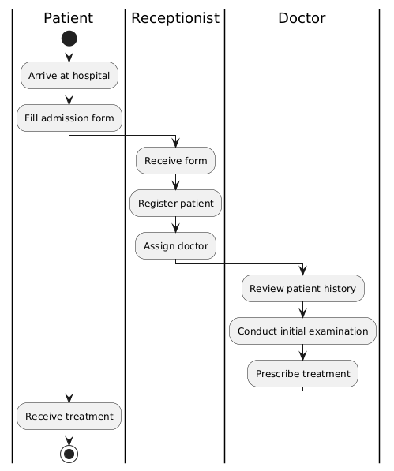

**Participants (Swim lanes)**

1. **Patient**:
   * Starts the process by arriving at the hospital.
   * Fills out the admission form.
   * Receives treatment at the end.
2. **Receptionist**:
   * Accepts the admission form.
   * Registers the patient into the hospital system.
   * Assigns a doctor based on availability or specialty.
3. **Doctor**:
   * Reviews the patient’s medical history.
   * Conducts an initial physical examination.
   * Prescribes appropriate treatment (could be medication, tests, admission, etc.)

Assignment 6 – Test Driven-Development

**Name**  – Yash Shivaji Lende

**Roll -No** – IT3116

**PRN**  – RBT22IT014

**Subject**  - Advance Software Modelling

**Project Structure: Java - Maven**

Testcase2/

src/main/java/ → Student.java

src/test/java/ → StudentTest.java

**Production Module:**

**public** class Student {

**public** String displayStudentName(String firstName, String lastName) {

**return** firstName + " " + lastName;

}

}

**Test Module:**

**import** org.junit.Test;

**import** static org.junit.Assert.*;

**public** class StudentTest {

**@Test**

**public** void testDisplayStudentName() {

Student student = new Student();

**String** studentName = student.displayStudentName("Narendra", "Modi");

assertEquals("AnshumanNain", studentName);

}

}

**Output :**

